SECTION AREAS AND HYDROSTATIC PARTICULARS
Group-6 | Container Ship March 9, 2026

Team members:
23NA10040 - Sanjay Krishna
23NA10033 - Tharun Kumar
23NA10021 - Manish Ramana
23NA10022 - Mukesh Vardhan

This document contains the following:
- Sectional area curve for the following conditions:
  - Draft = 0.5*Depth
  - Draft = 0.85*Depth
  - Draft = 0.98*Depth

- Hydrostatic particulars for the above mentioned conditions.

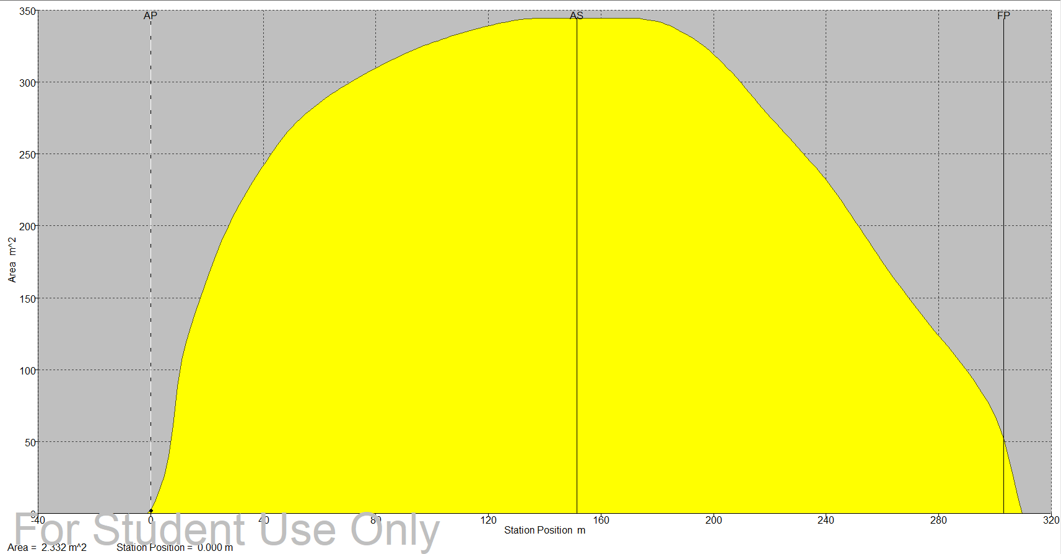

Figure 1: Sectional Area Curve at T = 10 m
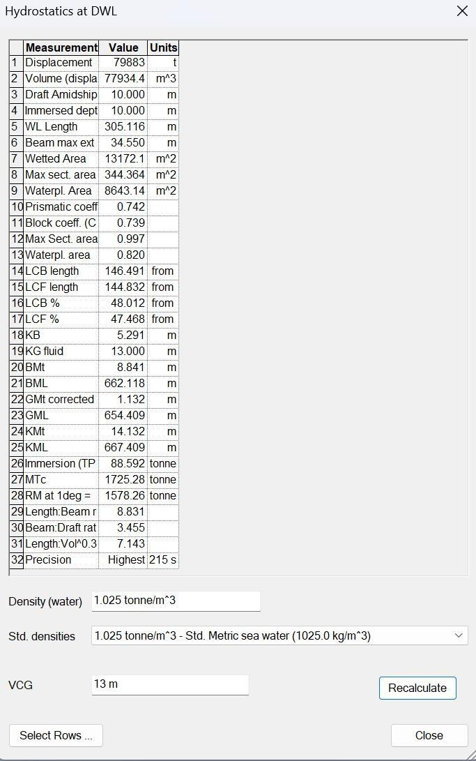

Figure 2: Hydrostatic Particulars at T = 10 m

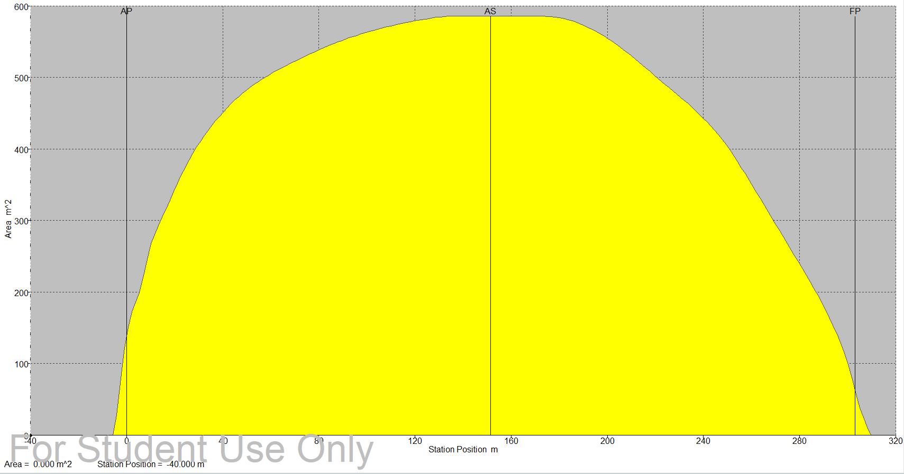
Figure 3: Sectional Area Curve at T = 17 m
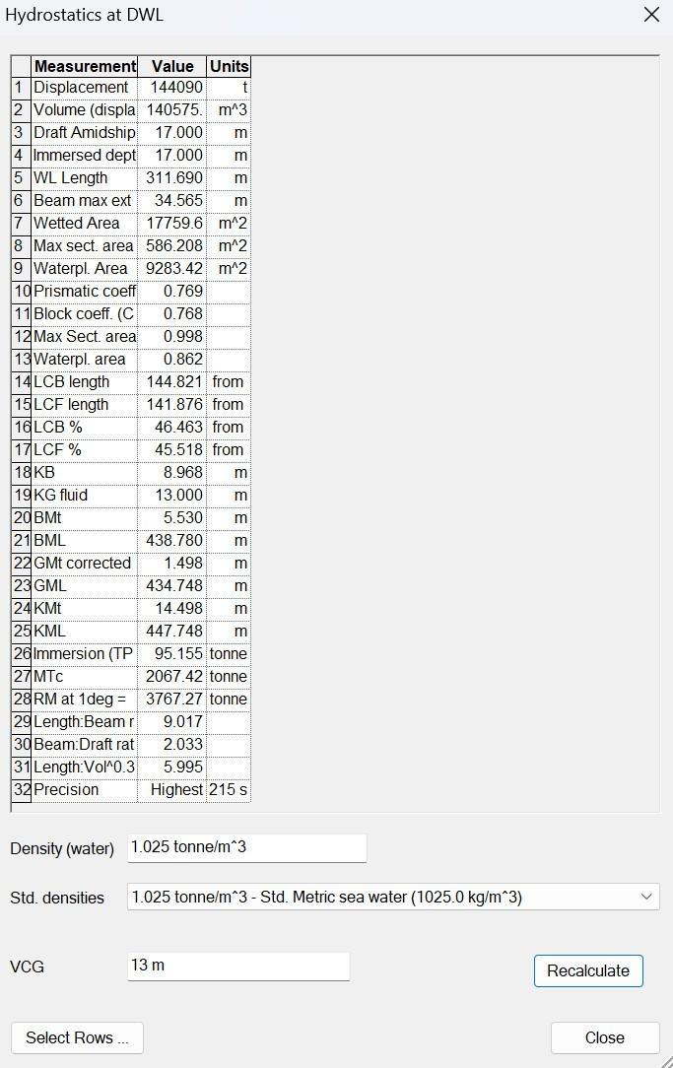

Figure 4: Hydrostatic Particulars at T = 17 m

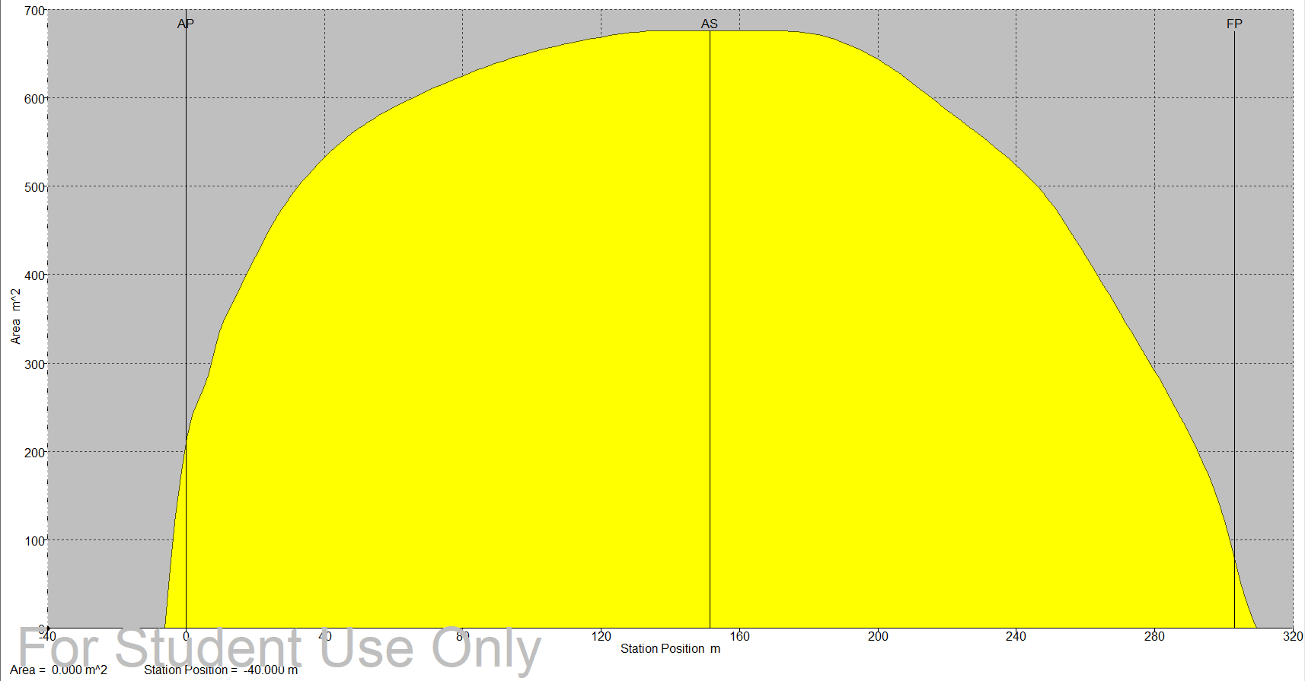
Figure 5: Sectional Area Curve at T = 19.6 m
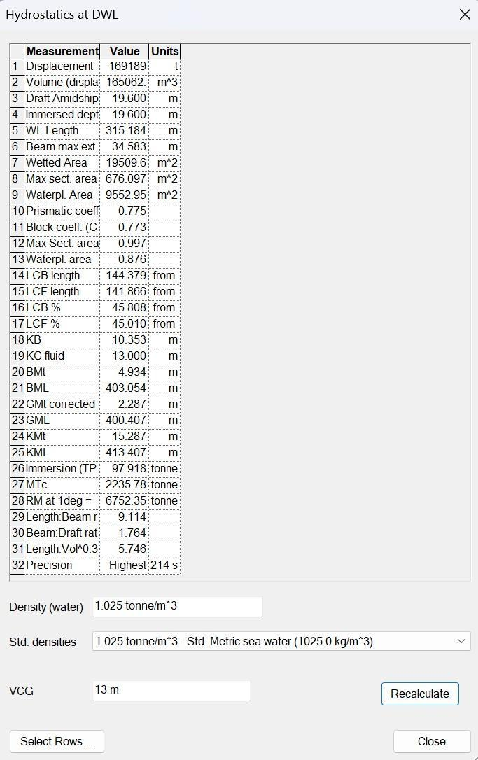

Figure 6: Hydrostatic Particulars at T = 19.6 m

